Leisure Boat Lift 1985 Tm

The Lifter mechanism, is a chain hoist. It has internal disc brakes, and brake pads, very similar to those on the wheels of your vehicle.
The down direction lowers the boat, while using disc brakes to control the descent. Depending on the size and weight of the boat these brakes need cleaning and etched surfaces to ensure smooth and quiet operation.
Qualified
Trades
Service Repair
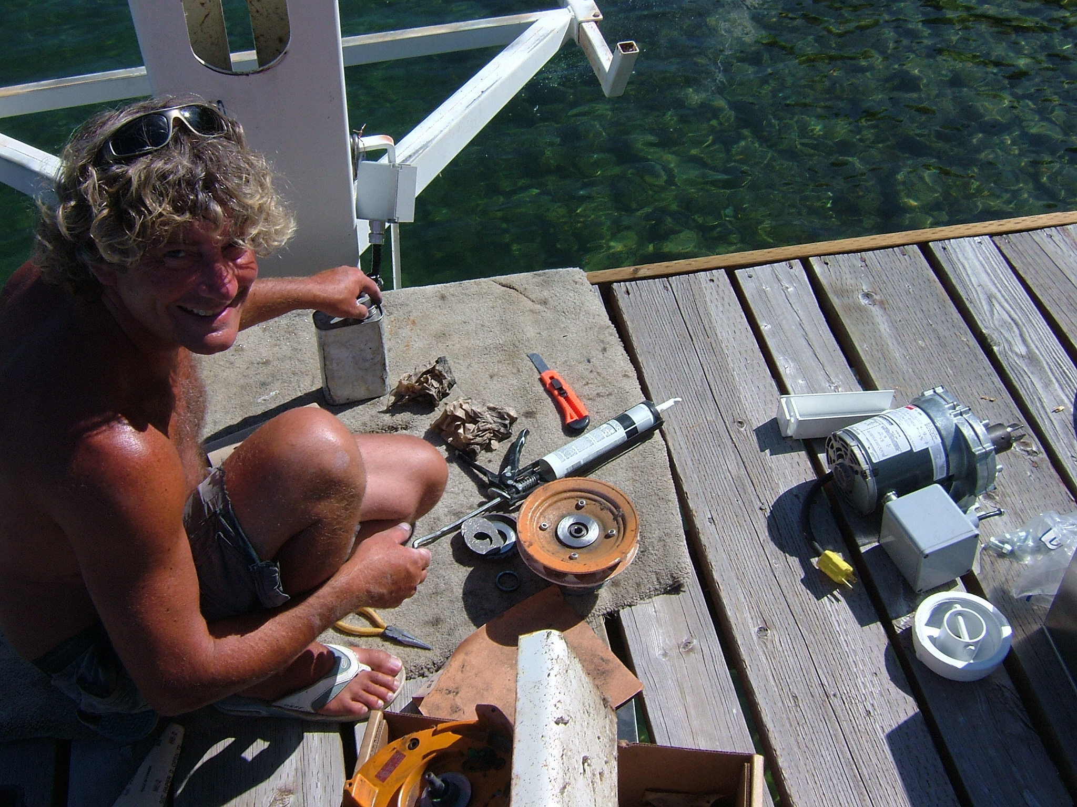“Lowering the Lifter in Timed Increments”.
An example would be: down position for 1 minute stop position for 20 seconds.
The up direction can be done all in one motion, lifting the boat clear of the surface of the water, until the propeller is also above the surface of the water.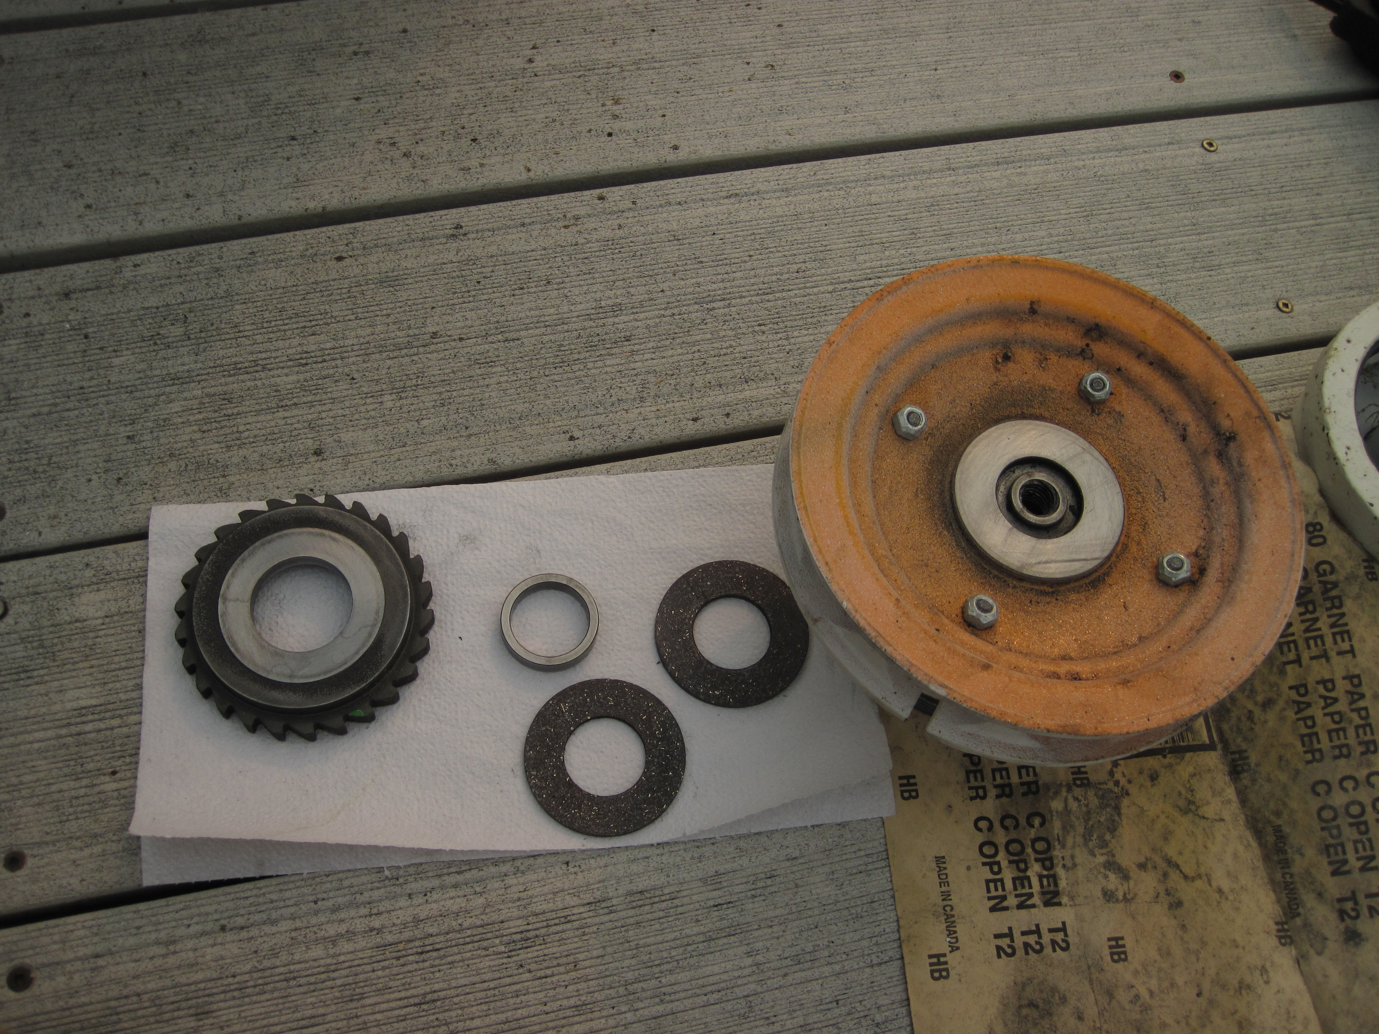
Disc Brakes dirty and noisy

Some things to know:
Weighs 1600 pounds.
Minimum height is 11 feet.
Maximum lift travel is 6 feet 1 inch
Minimum water level needs to be 6 inches, plus what the boat floats in.
Legs adjust over four feet individually.
Maximum height adjusted, of the lifter is 15 feet.
There is 18 inches of adjustment to consider the width of the boat.
One turn on the Crank Wheel equals half inch lift.
The full weight on the spinner is less than 25 pounds, when manually cranking.

Recommendations:

Always use the visual markings on the lift for limits and positions.
Stop lowering the boat before it actually floats and power off the lift.
Always make sure the engine leg is against the stop before raising the lift.
Learn the optimum depth for the boat to drive on and off all day without tying up.
Have the leg in the down position and the propeller clear of calm water when you’re finished lifting the boat for the day.
As the lake levels rise in Spring be sure to have Lifter adequately holding the boat well above the surface of the lake.
Lifting the boat adequately above of the surface, in stormy weather conditions is also recommended.
Never force the Crank Wheel in either direction.
Inspecting the Lift chain, is part of operating the lifter each and every time.

For service phone toll free:
1 800 661 2004

