Leisure Boat Lift tm

When the installation is complete, your boat and Leisure Boat Lift will be level in the raised position. Your boat will be held quite far forward, from the middle. This is because most of the weight of the boat is in the stern. The tower of the Leisure Boat Lift does its job relevant in the same way as the wheels and axles are established, on the boat trailer under your boat.
Failing to bring the boat to the Leg Stop, would be much the same as putting your boat halfway on its trailer. This too would cause a lot of wear and tear gathering a lot of attention from onlookers. Monitor this while lifting.

Lowering your boat from the Leisure Boat Lift is a matter of letting chain out of the chain hoist. This is a controlled drop. In no way and by no means is the boat powered down. Make sure the lifter is operating smoothly in both up and down directions. Looking at the chain and the marks set on the tower slot, become a part of operating the lift safely.
If you are initiating the down direction and nothing happens (the boat is not moving down), Stop! For various reasons, you are creating slack chain and creating a chance for the boat to free fall.
At this time check for the leg against the leg stop. To compensate start with the chain taut, so that it is tight with the weight of the boat again. Adjust weight forward, using objects other than humans to attain a better center of gravity. With tournament ski boats make sure of the ballast water has been drained. Keep viewing the lift chain as retrying the down direction once more.

Call for service to have the roller wheels lubricated in the tower and brakes cleaned in the chain hoist.
Tournament ski boats will be using a skeg or skag stop indicator, they usually have fins underneath the center of the boat.

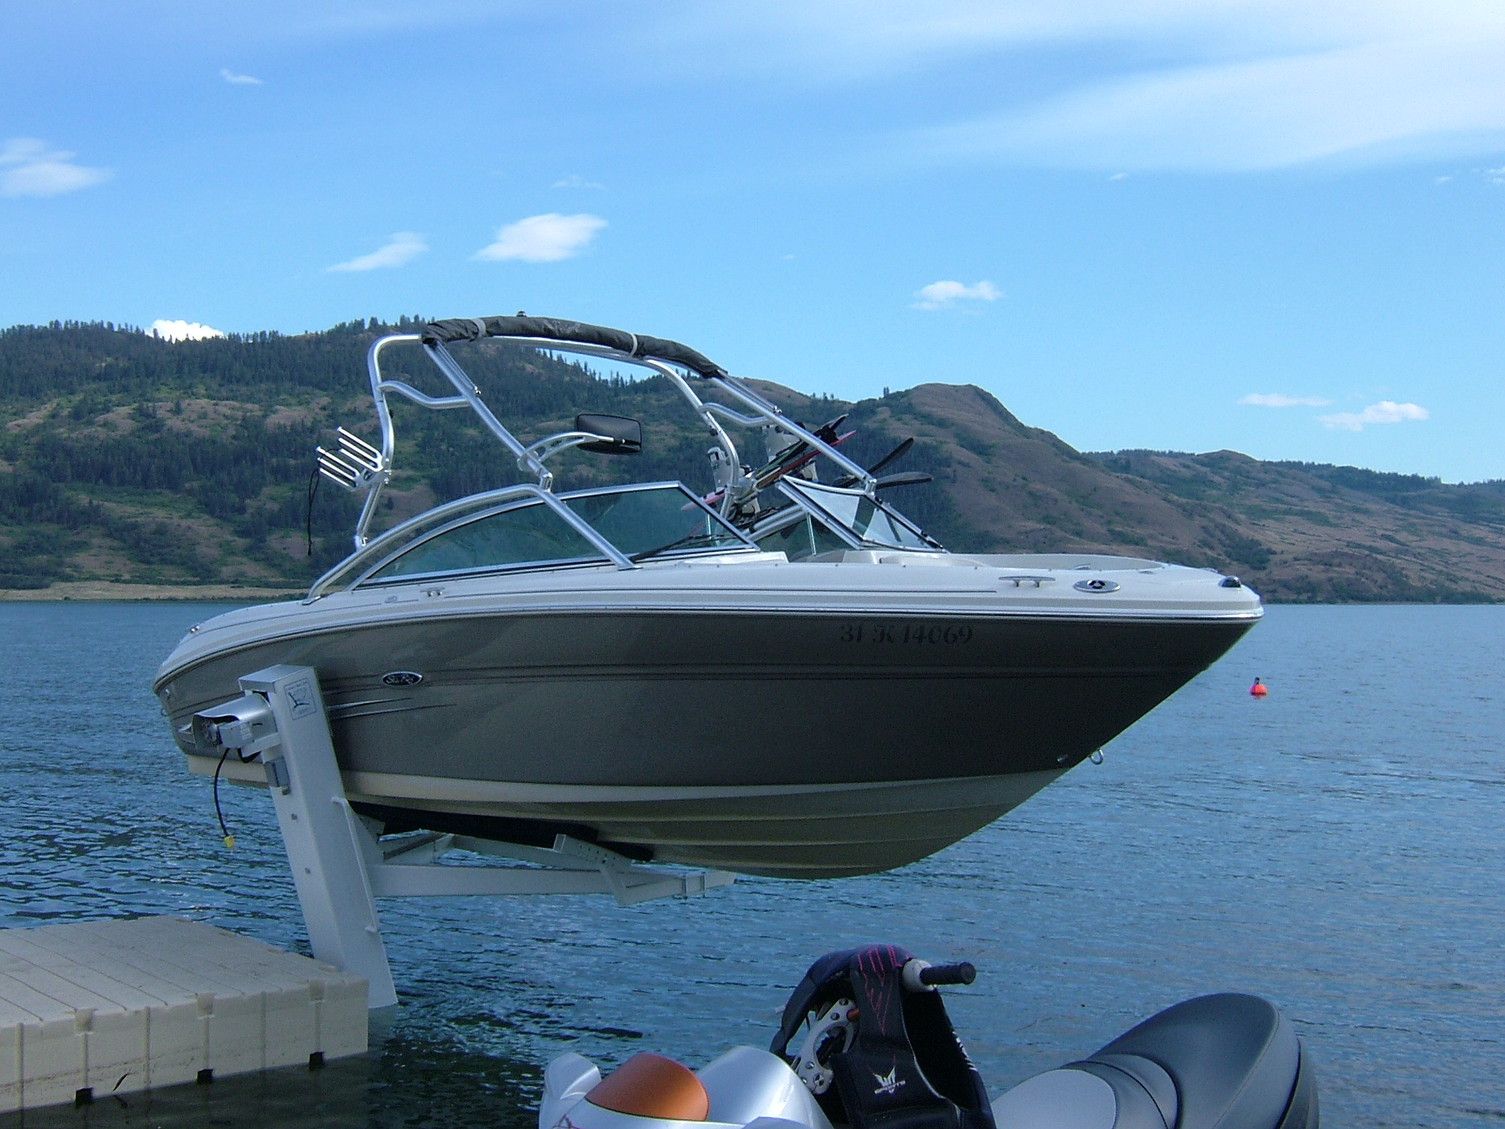

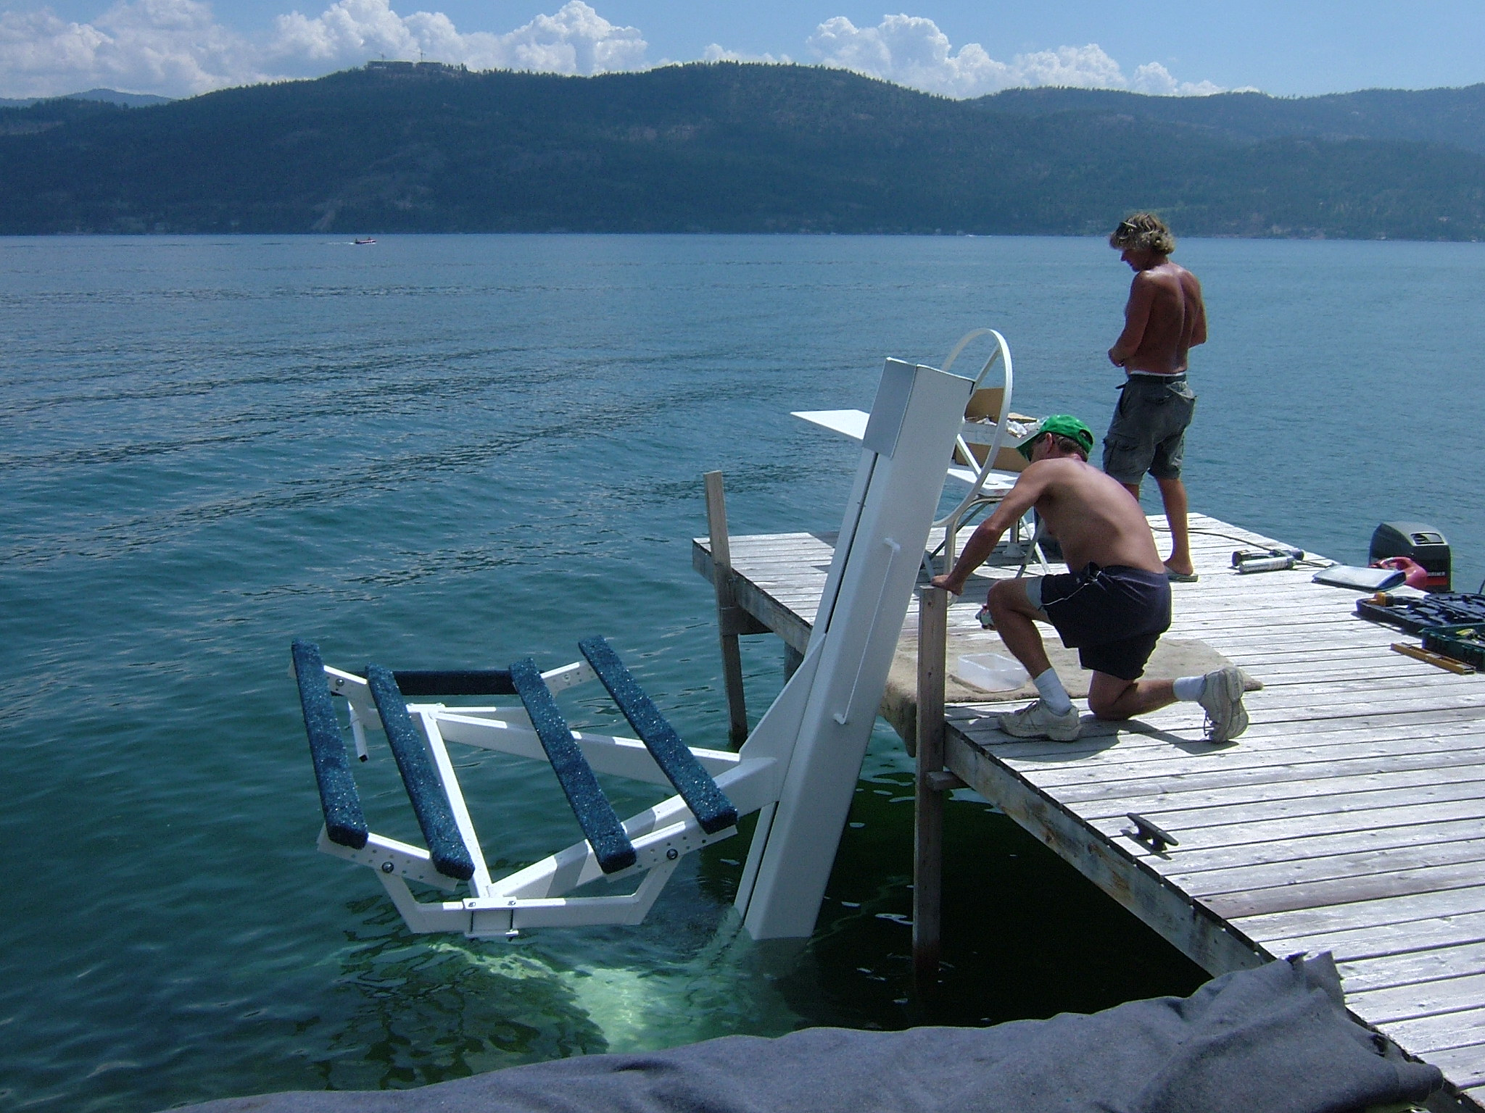

Each ‘carpeted Stop’ is designed as a ‘break away’ in the event that the boat comes on too abruptly. Damage will not occur to the components of the boat. The ‘sacrificed’ carpeted pieces are in stock and shipping is the same day as ordered. “In Store Pickup” by appointment is another option.

