Leisure Boat Lift Tm
Components at a Glance

Top Shroud
Spinner
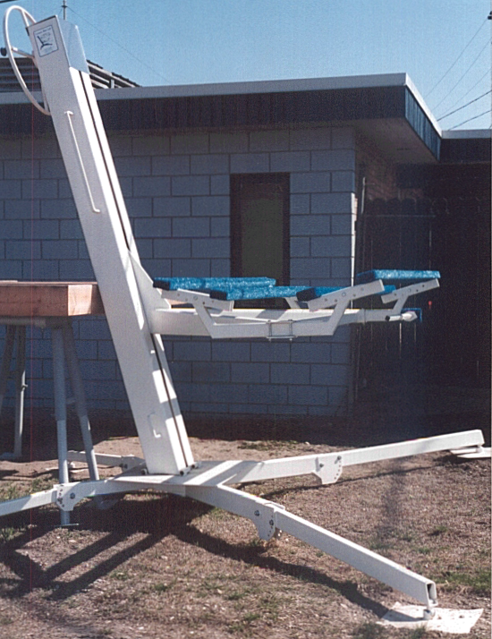
Carriage Cradle Arms
Seahorse Dock and Supports
Bi-Annual Service Chain Hoist
Carpet Bunks
‘D’ Handles
All Components Annual Service Requirement Inspection
Annual Service Requirement Roller Wheels
Engine Leg Stop
Tower Slot
X – Base and Legs with Pads
V-Blocks in Collectors
Bunks On Bunk Brackets
Standard Foot Pads
Small Front Retaining Pins
Leg Adjust Knee Plates
Large Rear Retaining Pins
Crank Wheel

