Leisure Boat Lift 1985 Tm

Thank you for choosing our product.

Please read these information pages and make them available to all who may operate your Leisure Boat Lift.
Please keep it handy for relatives, visitors and others concerned with the operation, maintenance and inspection of the Lifter.
In these pages are hints and tips to help with the safe operation of the Lift. Stormy weather, wave action and busy locations are addressed, along with pointers for first time users.
Under normal circumstances and seasonal conditions, Leisure Boat Lift will provide more than 25 years of service, extending the life of your boat and appreciating the value of your investment and property.
Knowing Leisure Boat Lift operations thoroughly, the inspection points and maintenance schedule, will offer you peace of mind and confidence for many years to come.

Five Years Limited Coverage:

Structural and mechanical failure under normal operating conditions.

Thirty day Guarantee:

Carpet, Wood Components, Mouldings, Epoxy Coatings and Finishes.

We reserve the right to justify any claims, before and after the expiration of the warranty period. This is concerning repair, replacement and relocation and re-establishing Leisure Boat Lift.

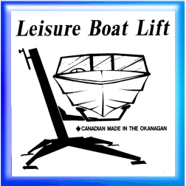Tm 