Leisure Boat Lift 1985 Tm

Under the surface inspection, a good idea any time the boat is away from the Leisure Boat Lift.

Retaining Bolt for Foot Pads
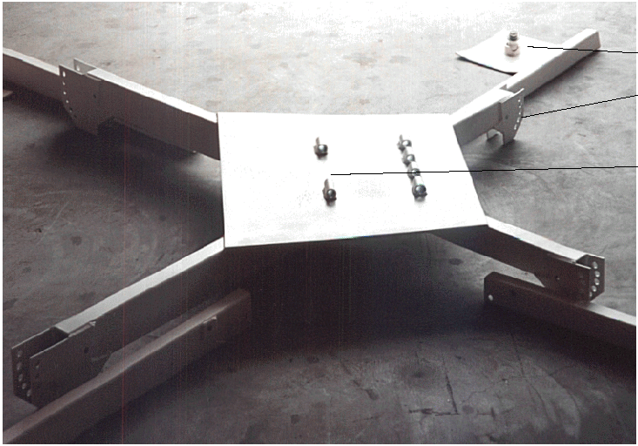
Retaining Bosses for Tower Pins
Outer Leg Adjustment holes
X-Base Inner Leg Adjuster Knee Plates

Loose retainers and fasteners can be checked with proper diving equipment and tools of the trade. Just using a dive mask will allow you to report any abnormal conditions on the Lifter and view it’s placement under the surface, on the lake bottom.

