Leisure Boat Lift tm

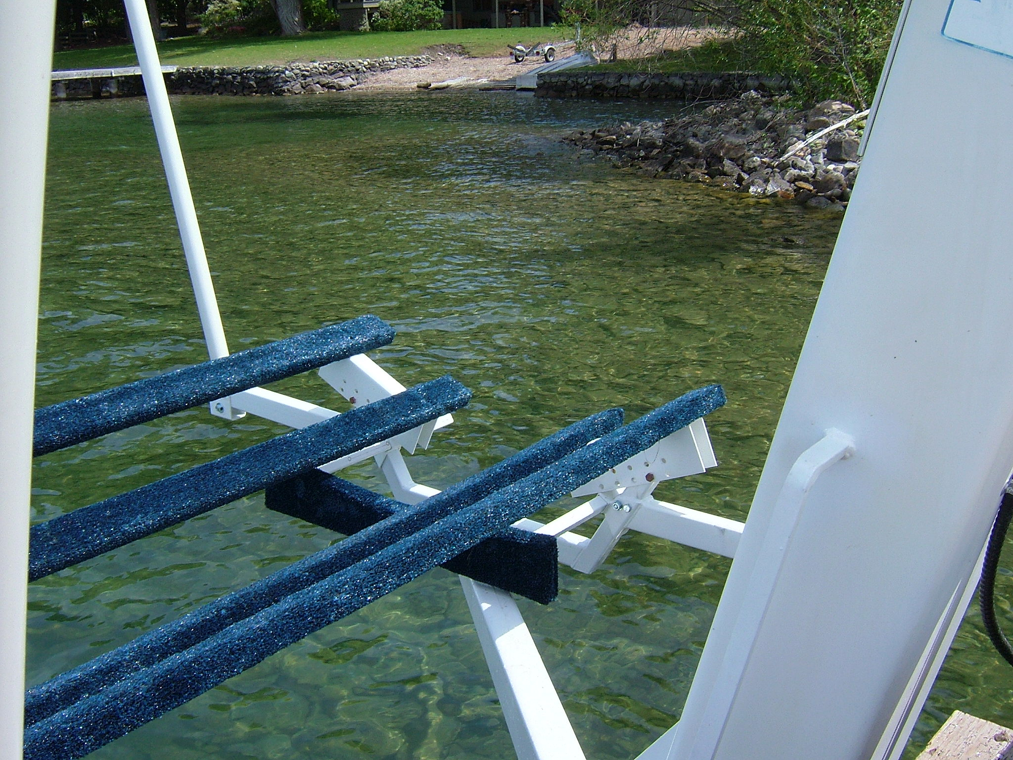

Call for service if you are lifting a different boat that certainly will need a reconfiguration according to length, width and ribs on the bottom of the boat.
When lowering the Leisure Boat Lift, never completely float the boat. Always leave some of the weight of the boat in the carpeted bunks.
Backing away from the Leisure Boat Lift, in reverse gear, use up to 3000 RPM. Safely steer the stern away from the dock.
Returning to the lift steer the boat between the bunks and power the boat gently onto the bunks and up to the leg stop. Powering back onto the lift is slightly easier, as the propeller is more effective in forward gear.
Lowering the boat to the appropriate depth is that key to the ease of operation. Visual marks are provided to help establish the optimum settings for driving on and off the lift.

Do not allow passengers in the bow while bringing the boat on the Lifter.

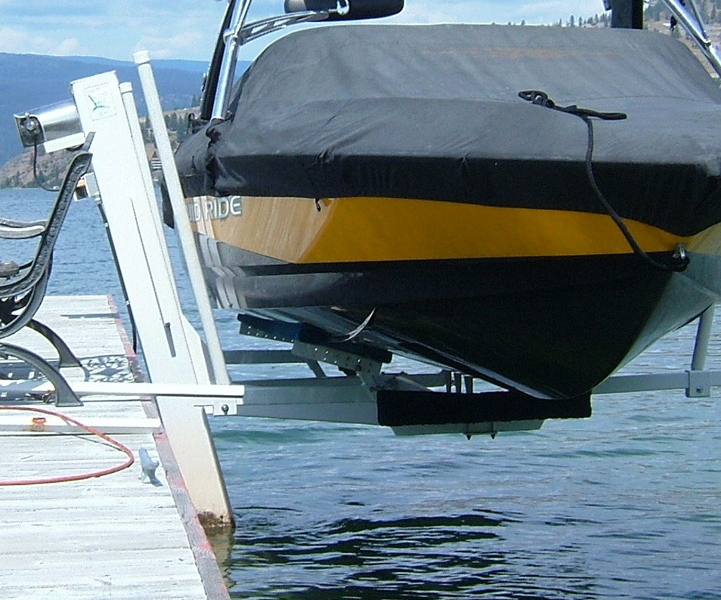
With concern of rough water conditions, have the lift bed slightly higher for leaving the lift under more power in reverse gear.
In turn, this slightly higher bed and bunk setting will aid coming back onto the bed system. It will keep the boat from going deep into the hollow of the waves and held much tighter while powering onto the bunks as they form a holstering effect.
Leisure Boat Lift is very forgiving in the lateral movement. Give and take with the waves assures no damage to structural strength of the boat.

