***1985 Leisure Boat LiftTm 2012***

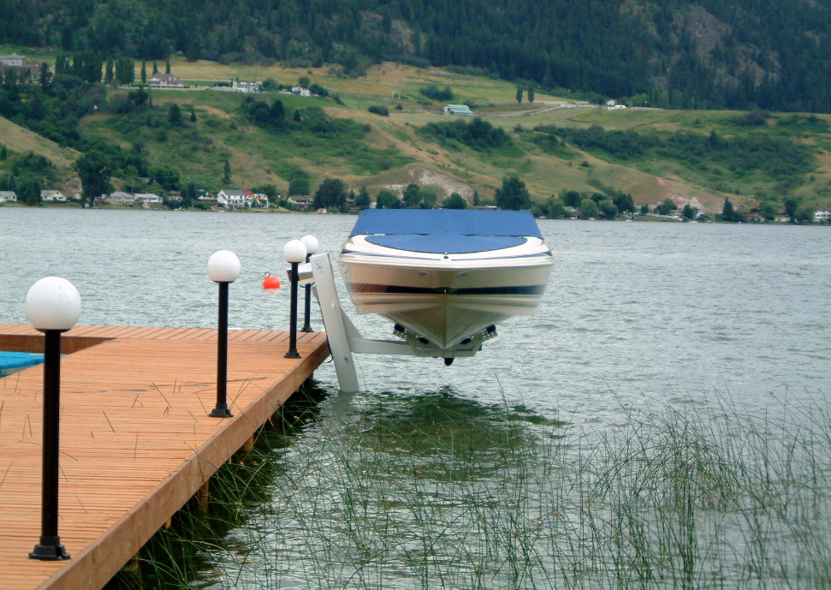

***DNR***

***Specialty Welding Ltd.***

**4209 – 24 Ave.**

**Vernon B.C**

**V1T 1M1**

[**www.leisureboatlift.com**](http://www.leisureboatlift.com)

**Email:**  [**dnr_lbl@telus.net**](mailto:dnr_lbl@telus.net)

**Local Phone: 250-542-3215**

**Toll Free: 1-800-661-2004**

**Fax: 250-542-3247**

